**JAVA-8 ASSIGNMENT-2**

Q1. Implement following functional interfaces from java.util.function using lambdas:

* Consumer
* Supplier
* Predicate
* Function

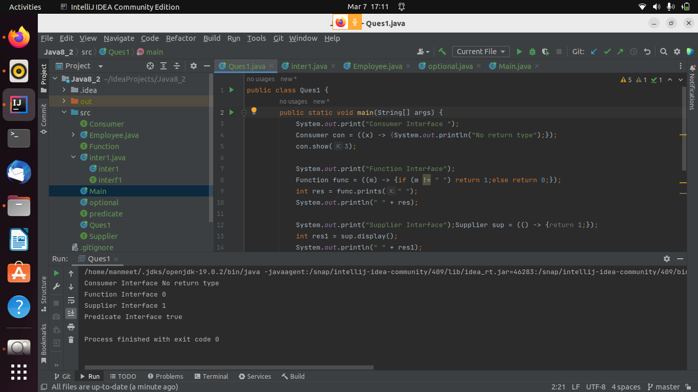

Q2. Create and access default and static method of an interface.

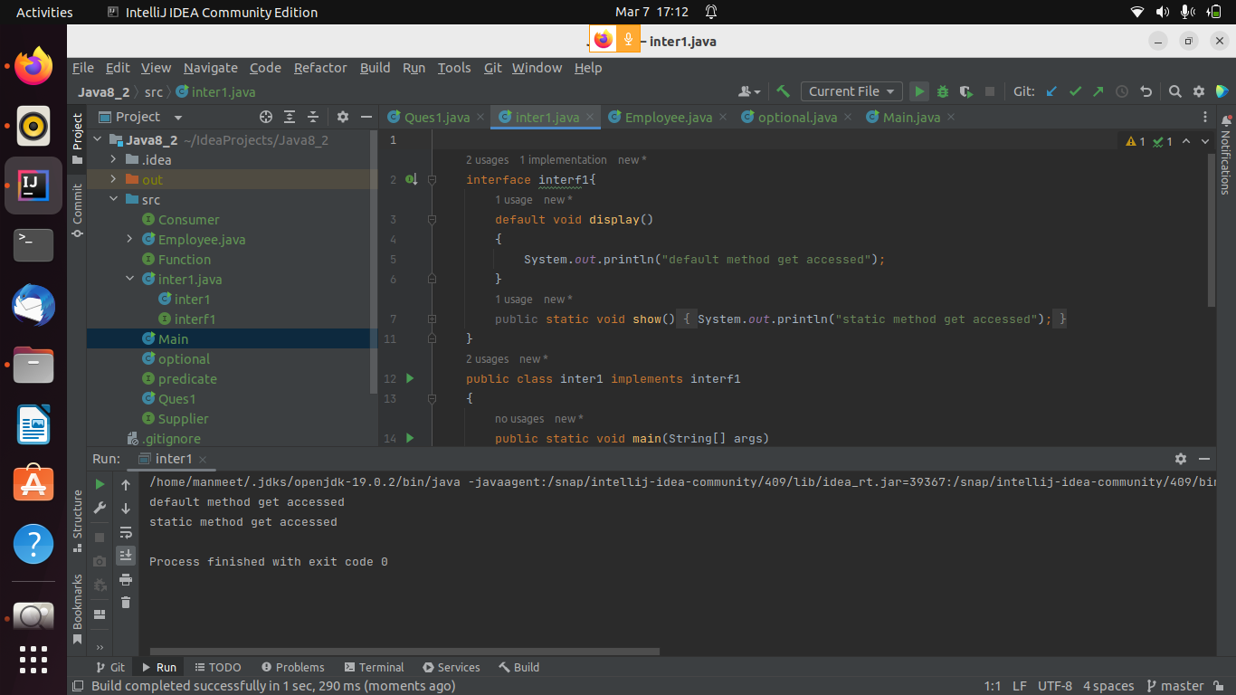

Q3. Sum all the numbers greater than 5 in the integer list using streams

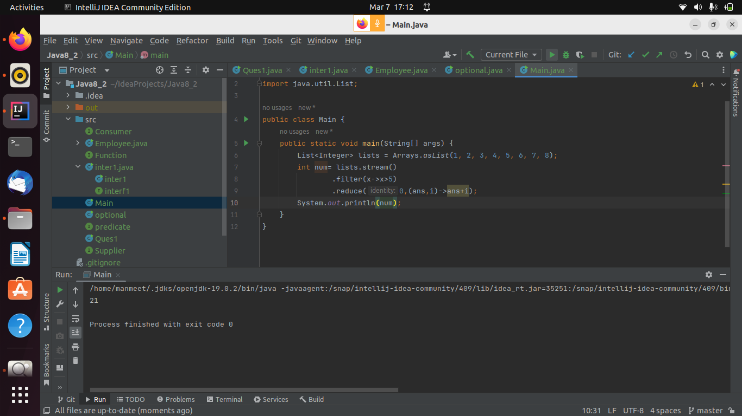

Q4. Write a program to showcase the use of optional class

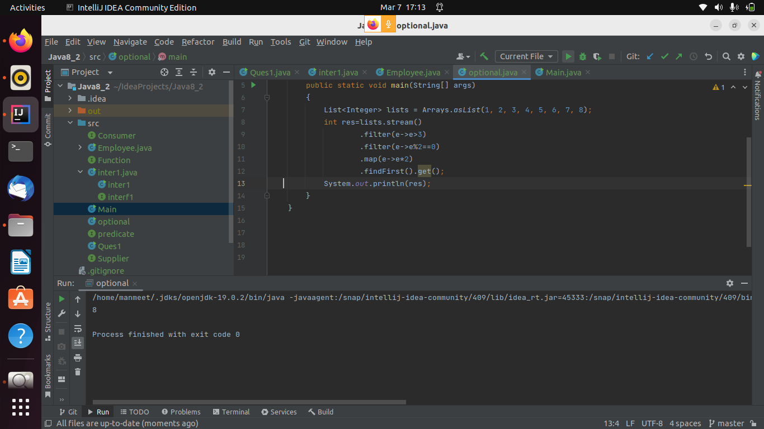

Q5. Given a list of objects of following class:

class Employee{

String fullName;

Long salary;

String city;

}

Get list of all unique firstNames of employees where their salary is less than 5000 and who live in delhi.

Note: Full name is concatenation of first name, middle name and last name with single space in between.

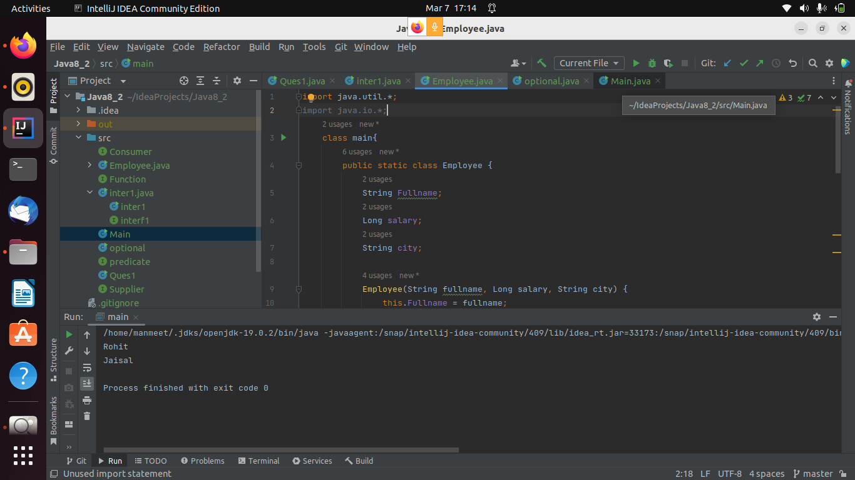

Q6. Using java 8 date/time api:

* WAP to get two dates from user and print if the first date occurs bfore or after the second date supplied by the user.
* WAP to print current date and time in 3 different time zones.

